**Software Architecture:**

Cartesian plane:

The Cartesian plane to be made is to have four quadrants that are:

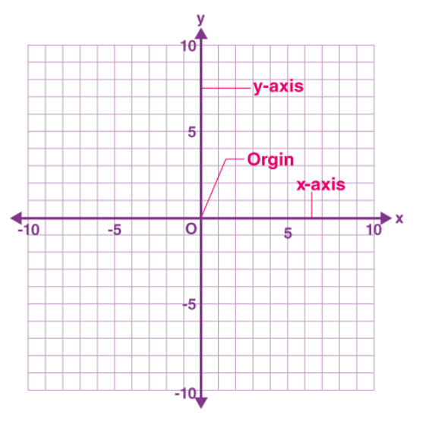

So that the origin that is the point (0,0) form the basis for all the other functions of the program to be specified, For an instance creation of a line requires two points to be used, Therefore both the points, if given vertices can find the exact length of the line, Area and perimeters of different figures to be used. Now here come the part of Full flagged geometric knowledge.

Point Snap:

The vertex of the mouse at any point in the Cartesian plane should be provided and shown either in a hovering box or at a status bar to be made at the bottom of the UI, to the X and Y coordinates of the point snap.

These points are further to be used in making of other figures whose functions are detailed below in the coming points.

Line:

Simple Line: A line can be created using two points. First point can be used as a starting point and further use the second point to use as the ending point of the line.

Multipoint Line: A multi-point line can be created by clicking on different points and the line should be automatically joint to make a connected of semi connected figure.

Drawing a Circle:

A Circle can be drawn by various means by the end user. Some of such methods are:   
1. Center Radius Circle: In this making of circle 1st point is to be taken as the center of the circle in the Cartesian plane. Now the other point has to be taken as the length of the radius required.

2. Two point Circle: In this making of circle 1st point is to be taken as the first tangent to the circle in the Cartesian plane. Now the other point has to be taken as the Second tangent to the circle and can be also used to set the size of the circle.

As the current application proposed is a basic program with various possibilities, we are implementing a Center Radius Circle. Now as we are using the Cartesian plane we can now find the location of the points on the drawing.

Drawing a quadrilateral:

There are different forms of quadrilaterals but the most common one used are to be given the privilege of easy creation in the program so the user finds it faster to draw images.

General quadrilaterals include:

1. Square
2. Rectangle
3. Rhombus

Now these above quadrilaterals are to be given certain shortcuts so as the user finds it easy to implement them in the drawing.

Other Shapes Even more than four sides can be implemented using a multi-point line.

Eraser: An eraser should be the part of the program so as to make the user free to draw and delete any part of the drawing.

Size Constraint for brush size and Eraser: There should be a universal or right click write size based mechanism so as to make the user enter the size of the brush as well as the eraser size to increase or decrease the thickness.

Select Tool: A select tool should be available in the system tray so as to select the part of the drawings that can be moved of copied.

Copy/Cut: The program should be able to copy the selected part of the image in the system clipboard.

Paste: The program should have a clear capability to paste any type of image data, into the drawing. Whether it be a

Open Issues:

Color picker:

Now, it is currently not decided whether to implement a color filler. Whether picker to be used should be able to pick from the whole Screen Snapshot or only from the drawing.

Color filler: The filler s